Tel :  E-mail:  Skype: | 0958652313  0687859975  Sorey14@gmail.com  Andrey Sokirko
Sokirko Andrey Leonidovich
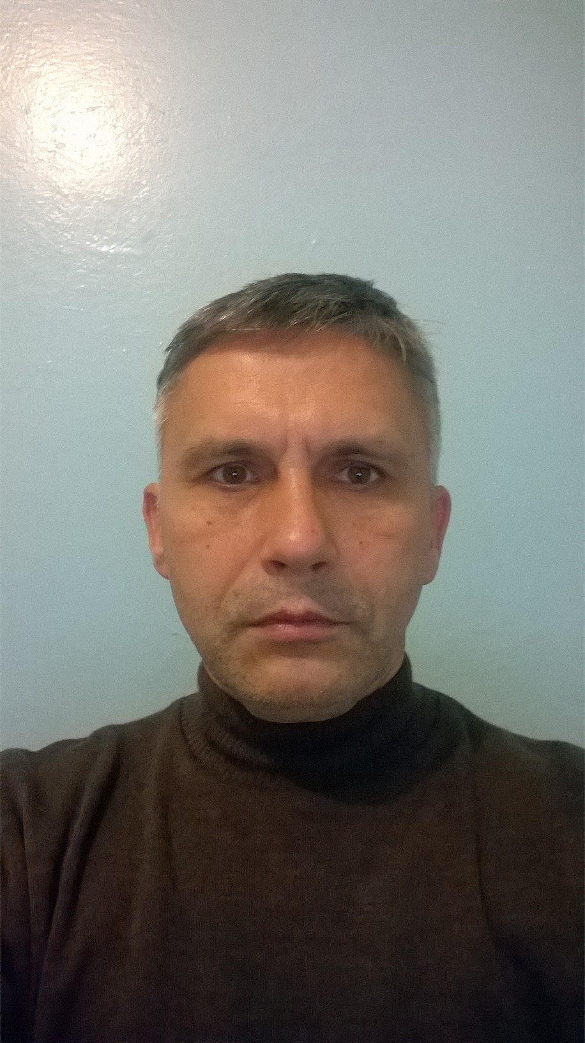
The purpose of the job search

Experience of work 1996-1998 Bank "Ukraine"
Engineer is a programmer

▪ Support, software upgrade opera day, treasury, currency posting, cash transactions, loans
▪ Consultation and training of employees
▪ Support for the functionality of servers and workstations
▪ Closure of the day, voucher
▪ Development of auxiliary programs

1999-2001 Tax Inspectorate
Chief Specialist

▪ Update, support over 30 workstations
▪ E-mail
▪ LAN support
▪ Routing
▪ Protection, security

2001 Kiev Institute of retraining of tax inspectorate executives Kyiv
Chief specialist of the department of informatization

▪ Installation, updating of the Accounting Software
▪ Written and installed software testing knowledge of PE managers
▪ Support for 60 workstations

2002-2007 Employment Center
The main specialist

▪ Administrator the Informix database server, installing clients programs, backup and recovery Informix DB server
▪ Install a new system for servicing unemployment population
▪ installed a miniATC
▪ Serving 2 servers(PDC and SDC) and 10 workstations
▪ Daily synchronization of Informix date with main server
▪ LAN and WAN support
▪ Install and update antyvirues programs
▪ Resolved collapse and not standart situations
▪ Diagnostics, repair of the PC

2007-2011 Tax Inspectorate
Chief Specialist

▪ Update, support for more than 30 workstations
▪ Diagnostics, repair of the PC
▪ (WEB-server (local Apache + PHP + oracle + corba), liga 8.15, Liga7, ftp, Buhsalary, dilkon-clerk, Best report forTAX, state register ....)
▪ E-mail FossMail server
▪ MS Office xx
▪ DR web enterprice Server 5 installation, setting, upgrade
▪ Installation, configuration, functionality support, backup of Oracle 9.2.0.8, recovery (Cold, logging).
▪ Intellect-Service Accounting Software
▪ Administrate 5 servers and 24 workstations windowsxp prof (installation and configuration)
▪ Development of auxiliary programs
▪ Support for LAN functionality and Internet network
▪ Routing, NAT, Active Directory, backup, Security, DNS, DHCP, DFS,

2012….
Freelance
▪ Rework functionality , makeup:
- CMS Open cart 1.5,
- Wordpress- Widget, layouts, custom fields….
- Laravel, Yii2 - changing makeup(base level)

WMI
▪ Education 1989-1994 Cherkasy State Pedagogical Institute of Cherkasy
▪ Faculty: Physics and Mathematics
▪ Specialty: physics-mathematics
▪ Certificates: SoftLine Kyiv

Experience

▪ WEB: HTML, CSS, Bootstrap, JS, PhotoSHop, JAVA (base level), AJAX, Angular (base level), OOP, PHP 5, OpenCart (1.5, 2.0), Wordpress
▪ Operating systems: Windows 2000 server, Windows 2003 server, windowsXX,
▪ OpenServer, EasyPhp
▪ YII2, Laravel, Angular 2, JQUERY, Angular 2, React(base)

Language: English (technical, preintermediate spoken), Ukrainian, Russian

Date of birth 1969

